AS Economics: Markets in action

Essay guide for F581 exam

Annotated essays

# Discuss the effectiveness of subsidies as a solution to market failure arising from positive externalities

Market failure is when the free market fails to deliver an efficient allocation of resources. Positive externalities are benefits of consumption or production to a third party. An example of this is education. Market failure arises from positive externalities because they are under consumed as the party does not understand it full benefits to society.

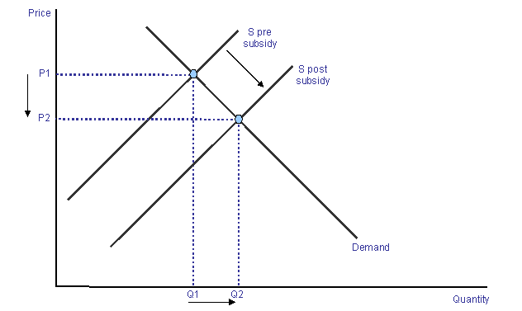A subsidy is a financial intervention provided by the government which lowers the cost of production which therefore should lower the price thus increasing the demand.

The introduction of a subsidy means supply shifts to the right because it reduces the cost of production from s pre subsidy to s post subsidy. This lowers the price from p1 to p2 causing an extension in demand shown by an increase in quantity from q1 to q2. This should result in higher output and lower prices.

The benefits of introducing a subsidy are that it increases consumption and the provision of merit goods which have positive externalities. This could correct market failure. For example, the government provide a subsidy for education called the EMA. This reduces the private costs of education and consequently people are more likely to stay on higher education.

There are also some disadvantages to providing subsidies. This is because the final cost of a subsidy usually falls on consumers (tax-payers) who might not benefit from this subsidy as they may not use the product.

Furthermore, if a subsidy is provided, this could lead to a misallocation of resources and by helping failing companies this could lead to further problems and thus distort market prices. This is because they protect inefficient firms who need to restructure – i.e. it delays much needed economic reforms.

Additionally, if they provide subsidies there will automatically be an opportunity cost as the money that they use for the subsidy could be spent correcting other externalities arising from market failure such as more money spent on healthcare.

The effectiveness of introducing a subsidy depends on whether the good is inelastic or elastic. If the good is inelastic, this means that a subsidy will not provide a sufficient increase in quantity as shown by the first graph where there is a large decrease in price from p1 to p2 but only a small increase in quantity from q1 to q2. This method can only be used if it is elastic because a small decrease in price from p1 to p2 provided by a subsidy will lead to a large increase in quantity demanded from q1 to q2. Furthermore, it is difficult to estimate how much the subsidy should be so this may not effectively correct market failure. 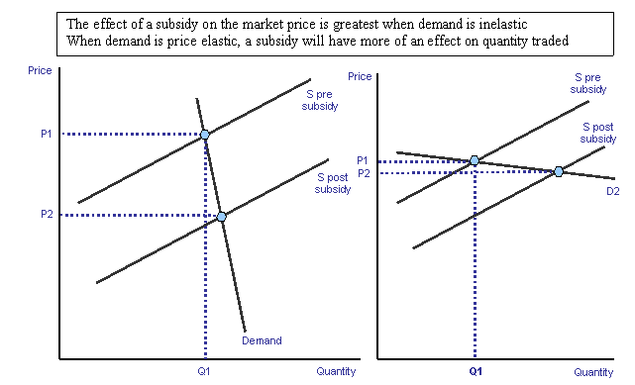

There may be another effective method to correct positive externalities arising from market failure instead of introducing a subsidy. This could be correcting information failure including advertising benefits of product which mean people will realise the full benefits of this merit good. Therefore, they will consume more of the product. This changes perceived beliefs of product and may encourage higher consumption of the good. However, this will also have an opportunity cost as the government have to use tax revenue to pay to correct information failure.

In conclusion, a subsidy would be the most effective method if the product was elastic. However, information failure is more likely to correct market failure if the good is inelastic.

**L1: Knowledge and understanding quiet evident, although some confusion at times.**

**L2: Applied to education and real world examples throughout.**

**L3: Analysis of how a subsidy works and its intended affects. The writer also includes a discussion on the drawbacks of subsidies. With one exception, there is support with diagrams that are well-explained.**

**L4: Evaluation is achieved, but just shy of excellent. Sound conclusions are reached and alternatives examined. There is discussion on the effectiveness of subsidies, however it would need to be more concise to achieve full marks.**

**Marks: 16/18**

# Discuss two possible solutions to the market failure arising from negative externalities

Market failure is when the free market fails to provide an efficient allocation of resources. Negative externalities are the costs to the third party which occur when private costs to the individual making the production or consumption decision, are less than the social cost.

Taxation is one solution to correct market failure which is arising from negative externalities. Introducing an indirect tax on products generates a reduction in consumption of the goods which produce the negative externalities.

Diagram to show why negative externalities are an example of market failure:

MPC (S)

0

Q1

Q

P

P1

MSC (S1)

Costs/ Benefits

Output/ Quantity

MPB = MSB (D)

Diagram to show the impact of tax:

S

0

Q1

Q

P

P1

S1 (S + TAX)

Price

Quantity

D

An indirect tax will internalise the costs. The government will place this tax on producers, which will increase their costs of production. The tax should be equal to the size of the external costs associated with the product, in the case of air travel, this will mean that the ‘polluter pays’ for the costs of the air and noise pollution.

The increase in costs of production will shift the supply curve from S to S1 in the diagram, this will lead to a higher price (P to P1), which more fully reflects the true cost of the product to society. The high price will lead to contractions in demand, and as a result, the tax is effective in reducing the consumption of the product from Q to Q1. However, the effectiveness of the policy depends upon the price elasticity of demand for the product in question. If the product has inelastic demand, consumers will be unresponsive to changes in price, so the producer will pass on most of the tax to them, giving them a high consumer burden, but they will still continue to purchase the product, often because the product is addictive or viewed as essential. This is a significant point, because if the tax does not reduce consumption, there will still be market failure. Based on this, tax may not be the best solution.

Another argument in favour of using indirect taxes to deal with negative externalities is that this policy will generate revenue for the government. This revenue will be particularly high if the tax is placed on inelastic products. Generating revenue is crucial for the government in the current economic climate as they have a large deficit; therefore this is a significant point. In addition, the revenue generated could be used to fund other schemes to reduce consumption of the product, such as education, which would solve the problem rather than just trying to change people’s incentives through the price mechanism. The money could also be used to try and minimise the costs on third parties, for example, paying for noise insulation for houses near airports. These points make a very strong argument that tax may be the best policy.

One problem with using indirect taxes to solve this problem is it will be difficult for the government to get the size of the tax right because the tax should cover the external costs/ negative externalities and this is virtually impossible to give a monetary value. If the tax was too small, it’d be ineffective, however if the tax was too high consumer burden would rise too much and citizens would stop buying the product altogether.

An alternative method to taxation is legislation. This could work by the government placing general restrictions on negative products such as cigarettes. A type of legislation the government could put on cigarettes is banning them from public areas such as pubs (which have already been done). The drawback of legislation is that it takes a very long time for laws/regulations to be completely enforced and for the law itself to be made official as acceptance of a law is a very long process.

On balance, I therefore think a combination of both taxation and legislation should be put on negative products such as cigarettes in order to reduce consumption most effectively. A decrease in consumption evidently lowers the external costs/ negative externalities produced by the product which benefits the general public who suffer from these. Taxation would mean that consumers pay, hopefully making the negative product more elastic so consumers will be more responsive to a change in price. However, if tax is not as defective as initially planned, for example, if people kept buying cigarettes because they’re so addictive, then legislation will be effective. Based on this, tax alone may not be the best incentive but when combined with legislation it is likely to be highly successful.

**L1: Content and knowledge are evident throughout. Two methods are introduced and defined.**

**L2: The discussion is in context of negative externalities and how legislation and indirect taxation can help reduce their resulting market failure.**

**L3: The analysis is weighed heavily in favour of indirect taxation and does not cover legislation in depth. The pros and cons of indirect taxation are evident, however the discussion on legislation leaves much to be desired.**

**L4: The evaluation is strong for indirect taxation as a solution to market failure resulting from negative externalities, but again there is little material on legislation which holds this essay back.**

**Marks: 11/18**

**Discuss whether health care in the UK should be provided by the government or the private sector**

It is debatable as to whether health care in the UK should be provided by the government or the private sector. If health care were to be provided by the government, it would mean that the taxes paid by UK citizens would be used to finance health care, and then it would be provided for free. However, if health care were to be provided by the private sector, it would mean that it would only be paid for as and when it is needed, and that the private business would receive all the income. Health care is a merit good, as it has more benefits than the consumers realise, for example, an individual having good health care means that they are physically able to work, and hence contribute to the economy. However, it could be argued that health care is not a merit good, as when someone is receiving health care, they are not working, which results in a less effective society. Health care has several positive externalities, for example, if an individual receives health treatment, it prevents the spread of disease to the rest of society.

It can be argued that health care in the UK should be provided by the government. If the government provided health care, it would be freely available in an unlimited supply, which would mean that people are more likely to consume it. This means that there will be an improvement in society due to an increase in positive externalities, for example, more health care will result in UK citizens being more able to work and hence contribute to the economy. However, if the government were to provide health care, it would be a public good, meaning that it has the feature of non-excludability. This means that it is impossible to prevent people from enjoying the product, even if they have not paid for it, meaning that it is unfair on the UK citizens who have contributed to the costs. Furthermore, the fact that it is a free product means that it could be taken advantage of – that people could consume the doctor’s time and their medicine, even if it is not necessary, therefore wasting the resources and the tax payer’s money. In addition, the free health care may result in increased demand, which is beyond the capability of the system to deal with, therefore services to the individual would be less efficient, therefore minimising positive externalities of the service.

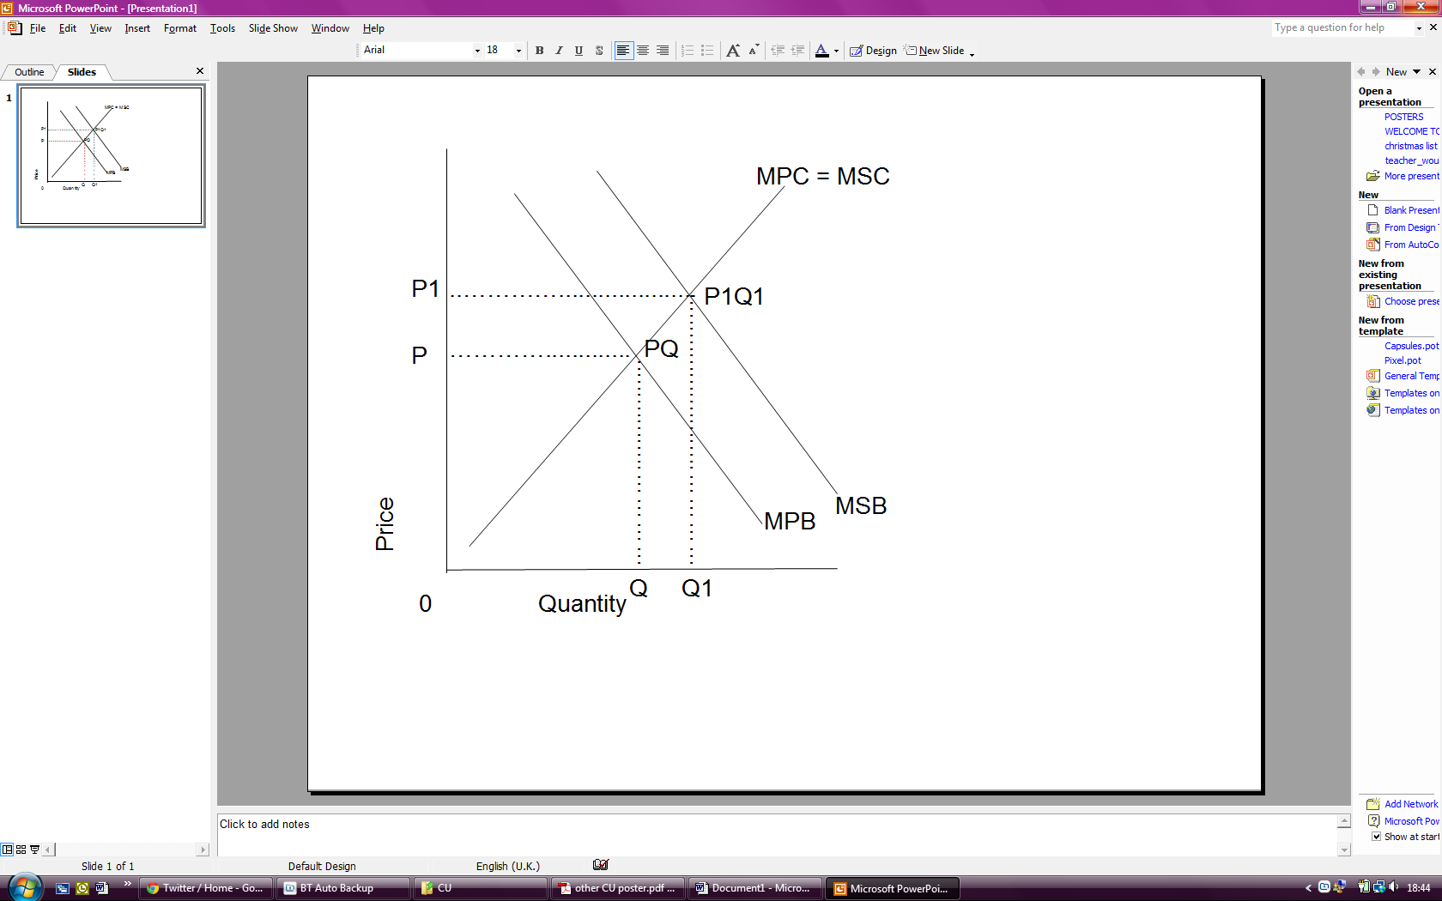 On the other hand, one can argue that health care should be paid for by the private sector. An advantage of this system is that it means health care is only paid for by the people who need it, and it is not a public good, meaning that UK citizens are not paying money towards causes which will not directly benefit them. Additionally, if people are aware they will have to pay for health care, it will give them an incentive to look after their health in order to prevent health care bills. Also, less demand for private sector provision of health care results in a more efficient service. However, the cost of this is that less demand will result in under consumption, as the consumption of the good will not be socially optimum. This can be shown on the graph below. PQ represents market equilibrium at the chosen level, where Marginal Private Benefits equal Marginal Private Costs however, P1Q1 is the socially optimum level, where Marginal Social Benefits are equal to the Marginal Social Costs.

In conclusion, the best solution would be a combination of both the private sector and the government provision of health care, which is the system that exists today. In Britain, the private sector exists, and provides what the public sector can not. The effectiveness of the public sector depends upon the attitude of the government and how much money they are willing to intervene. If the government did not invest a lot of money into the health care system, it would mean that there would be limited positive externalities and therefore private sector would be a better system, as the price would ensure an efficient system. Additionally, it is likely that a government provision of health care would not be sustainable, as the free provision would mean that the service is taken advantage of, and therefore would limit resources. However, the availability of the private sector provides UK citizens with an opportunity to opt for a more efficient service than the current government provision.

**L1: Good use of knowledge and demonstrated understanding of key terms such as public goods, merit goods, positive externalities, scarcity and negative externalities.**

**L2: Strong application to healthcare throughout. The discussion was held in context of the NHS from start to finish.**

**L3: A balanced approach weighing both the pros and cons of each type of provision – private and government. Supported with diagrams.**

**L4: A sound evaluation that reaches a justified conclusion. An examination into overall effectiveness of each method of provision and a final judgement suggesting the best solution is a combination of both methods.**

**Marks: 17/18**

**Discuss whether indirect taxes on petrol and diesel fuel in the UK should be reduced (June 2010)**

Indirect tax is a tax placed on producers by the government for goods such as diesel and petrol. Petrol and diesel are classed as de-merit goods as the products have more overall costs than the consumers realise. This results in an indirect tax being placed on the products in order to discourage consumption, thus correcting the market failure. However, government intervention sometimes leads to a more inefficient allocation of resources than the free market, hence government failure.

Indirect tax will internalise the external costs of petrol and diesel. The government will place a tax on the producers, thus increasing their production costs. The size of this tax should be equal to the size of the external costs associated with the product, thus enforcing the ‘polluter pays principle.’ If this were to occur, the diagram below shows what would happen in the market.

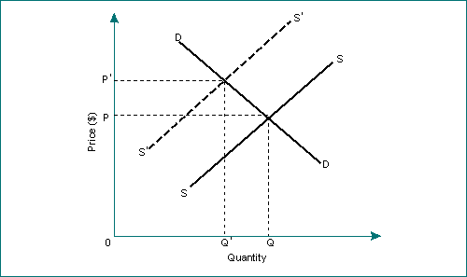

As there is an increase in production costs, there is a leftward shift in supply from S to S1. This causes an increase in price of the petrol and diesel from P to P1, as the business pass on a "consumer burden" to consumers in an attempt to cover their costs by. The consequence of this is a contraction in demand from Q to Q1, as the high prices discourages some consumers.

It could be argued that the indirect tax on petrol and diesel in the UK should be reduced, for various reasons. Firstly, the current tax placed on producers by the government is very high meaning producers pass on large "consumer burdens" to cover their good. As most means of transport rely on these fuels, the product is deemed "a necessity". High prices of the product mean consumers have less disposable income and result in high costs of living. In order to satisfy and maximise consumer welfare, it could thus be argued that indirect tax levels are reduced.

Furthermore, a reduction in indirect tax on petrol and diesel fuel could encourage more businesses to open in the industry. A smaller tax value would result in a reduction in production costs, which could encourage competitiveness within the industry. More businesses staying open within the industry and the possibility of even more businesses starting up within the industry will have a major long term benefit to the economy e.g. increased GDP and increase in jobs available (i.e. increased employment). This will also limit the possibility of a monopoly and will give consumers the option of choosing between competitors. This increase in competitiveness (more producers) will result in an increase in stability of prices. As there are many competitors, it **limits** the possibility of one producer determining the price of the fuel for the market in the UK, and all consumers having to pay this price because of the lack of competitors. When the tax is reduced, the level of competitors will mean that there is a stable price determined for the fuel by many producers and consumers are less likely to be charged extortionate prices.

On the other hand, many parties would argue that indirect taxes on petrol and diesel fuel should not be reduced. Firstly, as petrol and diesel are demerit goods there are negative spill over effects to third parties e.g. pollutants released to the atmosphere when the fuel is burnt. Therefore the indirect tax should not be reduced, as a high price of the fuel discourages consumption. The diagram below shows the effect on the market for petrol and diesel fuel if taxes were reduced.

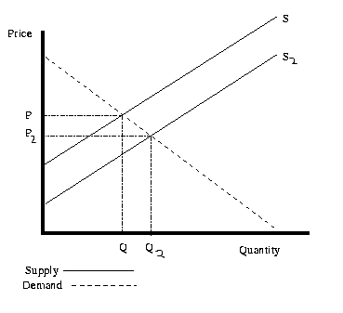S = supply for petrol with the current tax level

S2= supply for tax with reduced tax level

As the indirect tax on consumers is reduced, production costs go down causing a rightward shift of the supply curve. This causes a fall in price from P to P2 leading to an extension in demand from Q to Q2. This outlines the major problem of reducing indirect tax- the increase in demand. Due to the various negative externalities, the government should be attempting to discourage both production and consumption and a reduction in cost will have the opposite effect.

Furthermore, the tax on petrol and diesel fuel should not be reduced as the current high price of the petrol and diesel could lead to both consumers and producers exploring the use of alternative fuels such as bio-fuel, which are less damaging to the environment. This would result in businesses supplying petrol and diesel to lose a lot of business due to competitors selling substitutes.

Furthermore, if indirect taxes were to decrease there would be a decrease in government revenue; this could lead to a situation of opportunity cost as the government will have less money to invest in the public sector e.g. healthcare. This extra revenue could also be used to increase the advertisement of the dangers of demerit goods, in which would correct information failure, and reduce the costs to third parties.

However as petrol and diesel are inelastic goods due to it being viewed as essential, an increase in price will not cause a significant decrease in demand, therefore not correcting market failure. Also, increasing government revenue does not necessarily ensure the government will act in the best interest of the public - for example we cannot ensure that this money will be spent on public sectors like hospitals, therefore not maximising the welfare of the public at all. In addition, it is nearly impossible to place a monetary value on these negative externalities, as it is impossible to predict the extent of the damage caused to society.

In conclusion, keeping the indirect tax the same is better than reducing the tax. This is because indirect taxes generate revenue for the government which is likely to be invested in the public sector. Although we cannot be certain that the government will invest the money in the public sector, it is better to have the extra government revenue from the indirect tax than the smaller amount of revenue generated if the tax were to be reduced. Furthermore, indirect taxes will encourage more producers to provide alternative fuels, which will have a long term benefit to the public.

*I quite like this essay question as it does not leave room to consider alternatives. It invites the writer to discuss the argument for and against reducing the indirect tax on petrol and diesel fuel. There is some potential to discuss alternatives, but the context of the question dictates this is best avoided.*

**L1: Knowledge and understanding demonstrated well throughout.**

**L2: The discussion focuses on the issue of petrol and diesel throughout.**

**L3: The argument is well-balanced and analyses both benefits and drawbacks of raising/reducing the indirect taxes on petrol and diesel fuel.**

**L4: The evaluation is sound and justified. The prior arguments lead well into the final conclusion and it is clear to the reader that the writer has considered the issue in full.**

**Marks: 17/18**

**Discuss whether regulation is the most effective way of correcting market failure such as those arising from increasing carbon emissions. (18 marks)**

Market failure is when the free market fails to provide an efficient allocation of resources. A demerit good is one which is over consumed and over produced since consumers do not perceive the true costs of the good. These bring negative externalities. Negative externalities are the costs to third parties, of production and/or consumption decisions. In the free market, more than the socially optimum level of demerit goods is produced. One way to resolve this problem is for the government to regulate demerit goods, such as those increasing carbon emissions.

Regulation can be introduced in the form of an indirect tax. An indirect tax will internalise costs. The government can place this tax on producers, which will increase their costs of production. This can be a tax placed on the use of air travel or cars etc. The tax should ideally be the same as the size of the external costs associated with the good, in this case, the ‘polluter pays’ principle can be applied.

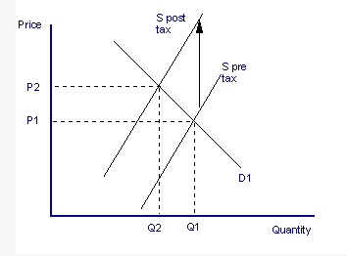

Due to the tax, the costs of production shift the supplier curve left from S to S1, which will lead to a higher price. This means that the price now better reflects the true cost of the good to the society. The higher price will result in contractions in demand and this means that the tax will be effective in reducing the consumption of products, in this case, those which increase carbon emissions.

Indirect taxes mean that the policy can generate revenue for the government. The amount of the revenue depends on the elasticity of the product. If the products are inelastic, the revenue will be higher. This is important for the government since in the current economic climate, they have a large deficit. This revenue could also be used to advertise and inform the public of costs of pollution. However, one of the problems with using indirect taxes to solve this market failure is that it will be difficult for the government to get the size of the tax right. It is not only difficult but almost impossible to put a monetary value on the external costs. For example, carbon emissions are produced from many different things and so it will be difficult to tax the right places at the right amount. If the tax is too small, it will not make a difference and so it will be ineffective. If the tax is too high, consumption may be reduced too much. Furthermore, whether the tax is effective or not depends on the elasticity of the product. For example, a tax on air travel may depend on the economic climate as well as if there are substitutes. Since travelling to other countries is easiest in planes, consumers may still be will to pay a higher price hence the tax maybe in effective. Based on this, an indirect tax may not be the best option.

An alternative method to using taxes is a tradable pollution permit. This is a permit that allows the owner to emit a certain amount of pollution and that, if unused, or partially used, can be sold to another polluter.

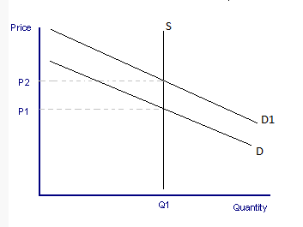

The supply is always the same because there is a fixed quantity decided by the government. This will work because firms which pollute more will have to buy permits and so pay for their pollution which might encourage them to become greener. This way the amount of carbon emissions can be reduced. However, the effectiveness of this policy depends on firms e.g. if a firm is rich, they can buy the permits without it affecting their revenue so not only will they feel that it is okay to pollute, the pollution will only be limited, not reduced. This is a crucial point because it means that firms will not realise the true costs and so they will continue to produce goods which create carbon emissions. Furthermore, it is very difficult to decide what the limit should be and so it could take a long time. Based on this, pollution permits will only work if they are clearly planned, and firms are encouraged to go greener.

On balance, I think in this case, a tradable pollution permit is the best option. This is because, due to the elasticity of the products which produce carbon emissions, an indirect tax will not affect the demand. Hence a pollution permit is the best way to set a limit to the amount of carbon emissions.

**L1: Knowledge and content demonstrated throughout with clear and concise definitions.**

**L2: Application to the issue of carbon emissions is evident throughout.**

**L3: Balanced analysis examining the benefits and drawbacks of indirect taxation as a form of regulation. Comparison included to tradable permits.**

**L4: Evaluation is sound and occurs throughout. There is some room for further clarity in the evaluation and this would strengthen an already well-written essay.**

**Marks: 17/18**

**Discuss whether taxation is the most effective solution to the market failures arising from negative externalities**

Negative externalities are spill over effects that affect the 3rd party and are the main cause of market failure, when the free market fails to allocate an efficient amount of resources. One of the main government interventions to correct market failure in the form of negative externalities produced from demerit good is indirect taxation. By putting an indirect tax on products it causes more negative externalities to that product in order to reduce consumption. An example of indirect tax is cigarettes; an indirect tax is placed on them to try and reduce consumption and to reduce the strain placed on the NHS from the negative externalities that arise from smoking.

By introducing an indirect tax it will help to solve this type of market failure as it internalises the external costs. The tax should be of equal size to the external costs associated with the product, in case of air travel, this will mean the ‘polluter pays’ for the costs of air and noise pollution. A rise in costs will reduce the supply and demand for the product and less will be produced and consumed as a result.

[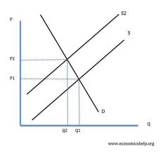](http://www.google.co.uk/imgres?q=supply+and+demand+diagram+with+supply+shifting+to+the+left&um=1&hl=en&sa=N&rlz=1W1SKPB_en&biw=1366&bih=556&tbm=isch&tbnid=nfXav4D6oBNmoM:&imgrefurl=http://www.economicshelp.org/blog/192/as-questions/finding-alternatives-to-oil-and-fossil-fuels/&docid=ZEBDfZjiIG6esM&imgurl=http://www.economicshelp.org/images/micro/supply-shift-left.jpg&w=448&h=421&ei=Mp_kTv2YCdSE8gOp1fD6Aw&zoom=1)

The decrease in demand will cause the amount supplied to reduce making the supply curve to shift to the left from S to S1, leading to a much higher price from P to P1, which reflects the more fully reflects the full cost to society. Less consumption of the product this is evident as quantity decreases from Q to Q1 while price increase from P to P1. However the effectiveness of the indirect tax will depend upon the elasticity of the product. If the product has inelastic demand, consumers will be less responsive to changes in price. This will create a high consumer burden as most of the tax will be passed onto them as the producers knows that the product will still be consumed usually because the product is deemed essential or addictive. This is a significant point, because if the tax does not reduce consumption there will still be market failure. Based on this tax may not be the best solution.

By using indirect taxes to deal with negative externalities it generates more revenue for the government. If the product is inelastic the revenue will be particularly high and as a result of this generating more revenue for the government. By generating more revenue the government can use it to fund other schemes, such as correction of information about education, which would solve the problem rather than just trying to change people’s incentives. The money could also be used to reduce the negative externalities affecting 3rd parties, for example advertisement try to correct the information about the effects of smoking. These points make a very strong argument that tax may be the best policy.

However, there is an issue with using indirect taxes to solve this problem as it is difficult to determine the size of the tax. The size of the tax should be the same size as the external costs to society which are almost impossible to determine for example if an indirect tax was placed on an aeroplane ticket to cover the pollution costs it would be nearby impossible to determine the monetary value of the pollution costs to society. If the tax became too big, a high consumer burden would be created and lead to a reduction in consumption as the product is elastic. Also if the tax is too small then it will be ineffective.

An alternative method to using tax is tradable pollution permits. These work between business to try and limit the amount of pollution. There is only a fixed amount of them produced to try and limit the amount of pollution caused. Certain companies pollute more than others, therefore as a result of this need more permits. Permits are able to be traded between companies. The effectiveness of this policy depends upon how wealthy the firms are as the richer firms could buy a majority of them to boost their revenue when it comes to trading. The permits do not necessarily reduce pollution but create an incentive for firms to pollute less.

On balance I think that indirect tax is one of the most effective solutions to solving market failure in the form of negative externalities. My main reason for thinking this is despite the amount of tax added being difficult to determine it will still internalise the external costs. Also, the negative externalities that arise from the market failure can be corrected by the revenue generated for the government from adding the indirect tax. Based on this I believe taxation is a very effective solution.

**L1: Strong knowledge of key terms and concepts including indirect taxes, negative externalities, tradable permits and polluter pays principle.**

**L2: Application of taxation to correcting market failures arising from negative externalities.**

**L3: Strong and balanced analysis of the issues with indirect taxation. The main concern limiting this analysis was the lack of a clear explanation of the negative externalities. The writer doesn’t fully explain why smoking or pollution cause negative externalities, it is left for the reader to assume. This limits your analysis.**

**L4: Evaluation is sound and could use little further development.**

**Overall marks: 16/18**

Discuss whether the Government should subsidise food prices (18 marks)

Financial intervention uses subsidies as a method of influencing the market price of the product. A subsidy is a payment by a governing body to encourage the production or consumption of a product to help correct market failure and market failure is where the free market mechanism fails to deliver an efficient allocation of resources.

Diagram to show the effects of a subsidy:

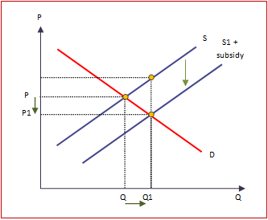

As subsidy shifts the supply curve to the right from S to S1; this lowers the price from P to P1 and increases the quantity from Q to Q1. Therefore a subsidy on food prices has caused there to be a payment to the firms which therefore reduces their production costs.

As the population continues to increase and the wants and desires also increase, consumers demand higher levels of food. Therefore a way in which the firms can supply this food without minimising revenues is through the introduction of these subsidies; this will maximise producer welfare as they will sell high levels of food and also maximise consumer welfare as the price of the products will be reduced. Moreover this will also maximise consumer welfare especially for the poorer individuals as the government are subsiding one of the main goods which makes up a large proportion of a poor persons income as food is essential; this will help to increase the real income of the households during the recession. Another advantage with the introduction of subsidies on food prices is the benefits from the increased merit goods consumed with the positive externalities which follow.

A diagram to show the effects of positive externalities.

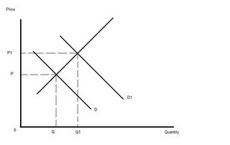

On the positive externalities graph Q indicated the chosen level of output but from the introduction of the subsidy the quantity increases from Q to Q1 to represent the socially optimal level. Therefore this will increase benefits to society as the merit goods will be consumed more, this will help to reduce the strain on the National Health Service as consumers will lead a healthier lifestyle.

However, subsidising food prices is a general subsidy placed on all food regardless of the status of the good. Therefore, merit and demerit goods will both be made cheaper to the consumer which, in the case of merit goods, is creating a good incentive to eat healthily, but, in the case of demerit goods, is encouraging people to eat unhealthy in the midst of a major obesity problem. The government has not got control of specific prices, but there are government legislations emphasising the health and nutritional content of food, so by reducing the prices of unhealthy food it is only encouraging ill-health. This increasing obesity issue, encouraged by subsidies, will place a strain on the National Health Service. These are the negative externalities produced if the government chooses to subsidise food prices.

Furthermore, another issue with subsidising such a vast market is determining the size of the subsidy, as it needs to reflect the growing demand for food without affecting other aspects. It is also likely, that one of producer or consumer will be unhappy with the chosen size of the subsidy and regardless, it will take the government’s time to decide on this causing an opportunity cost of where the time could be better spent.

As well as this, there is an opportunity cost on the money spent when subsidising the prices, this money could be spent on health care, education or many aspects which may be considered more important.

Finally, subsidising food prices generally will cost huge amounts of government spending, and as we are currently in an economic crisis, the revenue needed to pay for it needs to be generated most likely from further spending cuts or reductions to other public sectors.

On balance, the government should not subsidise food prices as the money and time involved could be better spent, and using them to subsidise food price may cause unrest and make the government unpopular. It would be an inefficient allocation of resources to subsidise food prices, resulting in market failure. Furthermore, the chosen size of the subsidy may not be accurate, causing government failure. However, it is difficult to be aware of how a policy such as this would work and how the public would react, as it may end up being very successful, very popular and very efficient.

**L1: The writer clearly understands the topic being questioned and most key terms (subsidies, merit goods, demerit goods, opportunity cost and positive externalities).**

**L2: The discussion is held in context of food production throughout.**

**L3: The writer provides a balanced argument with well-developed analysis. The diagrams for subsidising production and positive externalities are accurate and explained.**

**L4: The writer has balanced the argument and evaluated concisely. She examines the issues with determining the size of the subsidy, its opportunity cost and the potential for government failure in assessing the need. THE WRITER ALSO CONCLUDES WITH A DEFINITIVE ANSWER AND STATES THE GOVERNMENT SHOULD NOT SUBSIDISE FOOD PRICES. This is very important to remember in this question as it is asking an opinion.**

**Marks: 18/18**

Discuss whether tradable permits are an effective solution to correcting market failure, and reducing carbon emissions.

Tradable permits allow polluters to emit a certain amount of pollution and if un-used or partially used can be sold to others. Increased carbon emissions are an example of market failure. This is where the free market fails to achieve an efficient allocation of resources.

Tradable permits are an effective way of correcting market failure as they attempt to achieve government objectives of reducing emissions. By having a set amount of pollution allowed by the government, the demand for tradable permits increases and so does the price, encouraging firms not to pollute as shown on the diagram below.

S

D1

D

When the demand for permits increases from d to d1, the quantity supplied is fixed but the price of the permits increases from p to p1. A tightening of pollution standards can be shown by a shift left of the supply curve. This method of controlling carbon emissions should achieve the government’s desired environmental outcome consistent with the country’s maximum level of permitted emissions. One of the advantages is that it rewards firms who pollute less as they can earn money by selling their permits to less environmental firms. It should also result in the price of permits increasing to such an extent that even the richer firms will start to look for ways to reduce their carbon emissions.

However, there are limitations to pollution permits. Firstly, the government can only make an estimate to what they think is the acceptable amount of pollution being created. There could also be a problem calculating and actually distributing permits to polluters. The cost of enforcing and making sure that firms have sufficient permits to cover their pollution may also be a problem.

An alternative way of reducing carbon emissions is by legislation and regulation. This would mean the government could monitor firms on their pollution levels. Firms would be encouraged to abide to the restrictions make to avoid betting a fine or having their business closed. This would decrease their demand to create carbon emissions.

S

D

D1

The leftward shift of the demand curve from q to qi caused by the restriction of emissions causes the price to increase from p to p1 and quantity demanded to drop from q to q1. The new equilibrium moves from pq to p1q1.

In theory legislation and regulation should correct market failure caused by carbon emissions, however not everyone will abide to the law. There would also be the problem of the cost of enforcement and similarly to pollution permit the government would have to make an estimate to the value of the acceptable amount of carbon emissions allowed.

On balance, I think that pollution permits are the most effective way of reducing carbon emissions as they internalise the costs of polluting unlike laws and regulations as their cost of enforcement is likely to be paid for by taxes. They also have the benefit of rewarding more economic firms.

**L1: Knowledge and understanding of tradable permits, market failure and legislation.**

**L2: Explanation and application of tradable permits to correcting the market failure that results from pollution. However, further explanation of the market failures resulting from pollution are necessary.**

**L3: A thorough analysis of tradable permits and examination of an alternative. With improved labelling of diagrams and further analysis, this would be strong.**

**L4: Evaluation is reasonable and evident throughout. The final conclusion seems brief, however, the evaluation has been carried out earlier. This allows the student to achieve solid evaluation marks.**

**Final marks: 15/18**

**Quite often it can be stated that the lack of information on the dangers of smoking lead to market failure. To what extent is the improved provision of information the best method to correct this market failure?**

Market failure is when the free market fails to deliver an efficient allocation of resources. When applied to the problem of smoking, it is seen that as smoking results in negative externalities, there are many problems that arise from its consumption. Therefore this is an example of market has failed to provide an efficient allocation of resources so that there is an effective output. The lack of information is considered information failure; when either the consumers or producers are unaware of all the information that there is available, in this case smokers are those who have a lack of information.

The improved provision of information could be thought of as the best method to correct market failure because it would result in a decrease in consumption of this demerit good. In order to decide if this is the most effective way to correct market failure I will consider the costs and benefits that would result from implementing this and I will compare this to an alternative method of taxation.

Diagram to show the impact of improved provision of information:

S

D

D¹

The improved provision of information will ensure that consumers are more aware of the dangers of smoking for them and to others - therefore they will change the perceived ‘costs’ and ‘benefits’ of the consumption of this good. This is most likely to change the incentives of consumers by educating them on the full problems that arise from the problem of smoking. The correction of information failure will shift the demand curve to the left due the decrease in demand from D to D¹. This shift will more fully reflect the true cost of smoking on society and will result in a change in how consumers perceive the dangers of smoking. The consumers are less likely to over-consume the product if they have better knowledge of its dangers. This will successfully reduce the consumption of smoking which leads to market failure and so this could be considered the best method to correcting this market failure. Although it may not effect consumers drastically and reduce all consumption of smoking straight away, it is likely to have some effect on consumers and so they are less likely to continue smoking.

Another advantage the provision of information surrounding the consumption of cigarettes is that it is likely to prevent market failure in the future. The improvement of provision of information by the government through advertisements and appeals is likely to enhance the knowledge of society before they begin to consume in the first place. This will be preventative of market failure, if the government can prevent the consumption of this good before people become addicted to it. It will be considerably more difficult for those who smoke to stop smoking once they become addicted to the product, as it is a psychological addiction. Hence it will be more effective for those who do not consume the product yet as they will able to make a more informed decision, rather than those who are addicted who will be subject to bias because of their addiction. Examples of ways in which the government can improve the provision of the product are through advertising on cigarette packets; better education within schools of the dangers of smoking (to the whole of society rather than just the individual making the consumption decision); more detailed information on the dangers; further expansion of health warnings through advertising.

One problem with using provision of information is that it depends on the effectiveness of the policy as to whether and how much the consumers will react to this change in information. It is difficult to predict if the advertisements and campaigns will have enough of a significant effect to change the incentives of people who purchase this good. It has been seen that advertisements for smoking have become more shocking recently which could be due to consumers being unresponsive to improvement in provision of information. The reason why consumers are likely to be unresponsive to this good is because the good is inelastic, which results in consumers are unlikely to be responsive to changes in information surrounding the problem of smoking. This can be seen in the proof that the majority of society realise that smoking is bad for them, yet they still choose to smoke, because for them perhaps the benefits of smoking will always outweigh the costs of smoking. Perhaps for the individual the effects on the individual themselves are not powerful enough, because they are yet to have seen the true risk, which is death. This could result in government failure, whereby the governments intervention results in a more inefficient allocation of resources i.e. consumers consume more cigarettes. This is significant because this could mean that provision of information is not the best method to correct market failure. In contradiction to this, even if it does not affect consumer’s consumption noticeably it will result in a decrease in consumption.

An alternative method to provision of information as the best method to correct this market failure is through indirect taxes. This will reduce the consumption of smoking because of the implementation of the indirect tax.

Diagram to show the impact of a tax on a supply and demand diagram:

The effect of the indirect tax on the supply and demand diagram is that it will shift the supply curve to the left from S to S¹. The reason why it will shift the supply curve is because the government will make producers pay a tax for producing their good. This will internalise the external costs that are produced from the smoking which results in market failure.

S¹ (S+Tax)

S

D

Producers are likely to pass on the tax to consumers because they know that they are still going to be willing to pay the extra amount for the product because the product is inelastic. This change results in a more effective reflection of the full cost to society. The price of the cigarettes will increase which will result in a contraction in demand. Therefore consumers are less likely to consume the cigarettes which result in market failure. On the other hand it could be considered that consumers are unlikely to be very responsive to the change in price because the good is inelastic. This would mean that it would be unlikely to be very effective as a solution to market failure produced by the consumption of cigarettes because consumers are unlikely to reduce their consumption of them due to their addiction. This is significant because this means that this type of alternative is not likely to be the best method to correct this market failure. It can also be proven that this is not the most effective way to prevent market failure because the government already do implement indirect tax on cigarettes, and still there is no reduction in the consumption of this product.

This is a similar disadvantage as with provision of information – but provision is likely to be slightly more successful because people are more likely to stop consuming cigarettes due to the overcoming shock that certain types of advertising can have. Recently there has been a further focus by the government on advertising that has the incentive of shocking the audience which results in a movement towards correcting market failure; there use of children to appeal for their families to stop smoking is an example of how horrifying yet effective the improvement of provision of information can be.

I think that improved provision of information is the most effective method to prevent market failure due to the consumption of cigarettes due to the fact that compared to alternative methods of government intervention I believe that this is the most effective. From my point of view it is the most effective to the extent that it does not completely correct market failure because those who are addicted to cigarettes are not as inclined to stop even when they are exposed to more shocking advertisements. Therefore a combination of many of the government interventions could be a more effective method to aiming to correct market failure.

**L1: Knowledge and understanding evident with correct definitions.**

**L2: The essay was written in context of smoking throughout and the negative externalities of smoking could be further discussed. Be sure to expand on your point that smoking causes negative externalities. It is evident that they contribute to illness and sickness within society – but what are the further reaching implications (e.g. absenteeism, NHS resources and loss of productivity).**

**L3: There is a thorough analysis carried out weighing up the benefits of the provision of information with strong understanding of the benefits and drawbacks. It is balanced and includes support with diagrams explained. The diagrams will require more accurate labelling and thorough explanation. There is some confusion with the understanding of indirect taxes and their impact on consumption – however the writer does offer a sound analysis. As this is related to an alternative to the method listed in the question, it is assessed to a lesser extent. The majority of analysis points were awarded for the pros/cons of the provision of information.**

**L4: The evaluation is justified and supported. It could be improved with a more thorough and precise conclusion, however it is still strong.**

**Marks: 15/18**